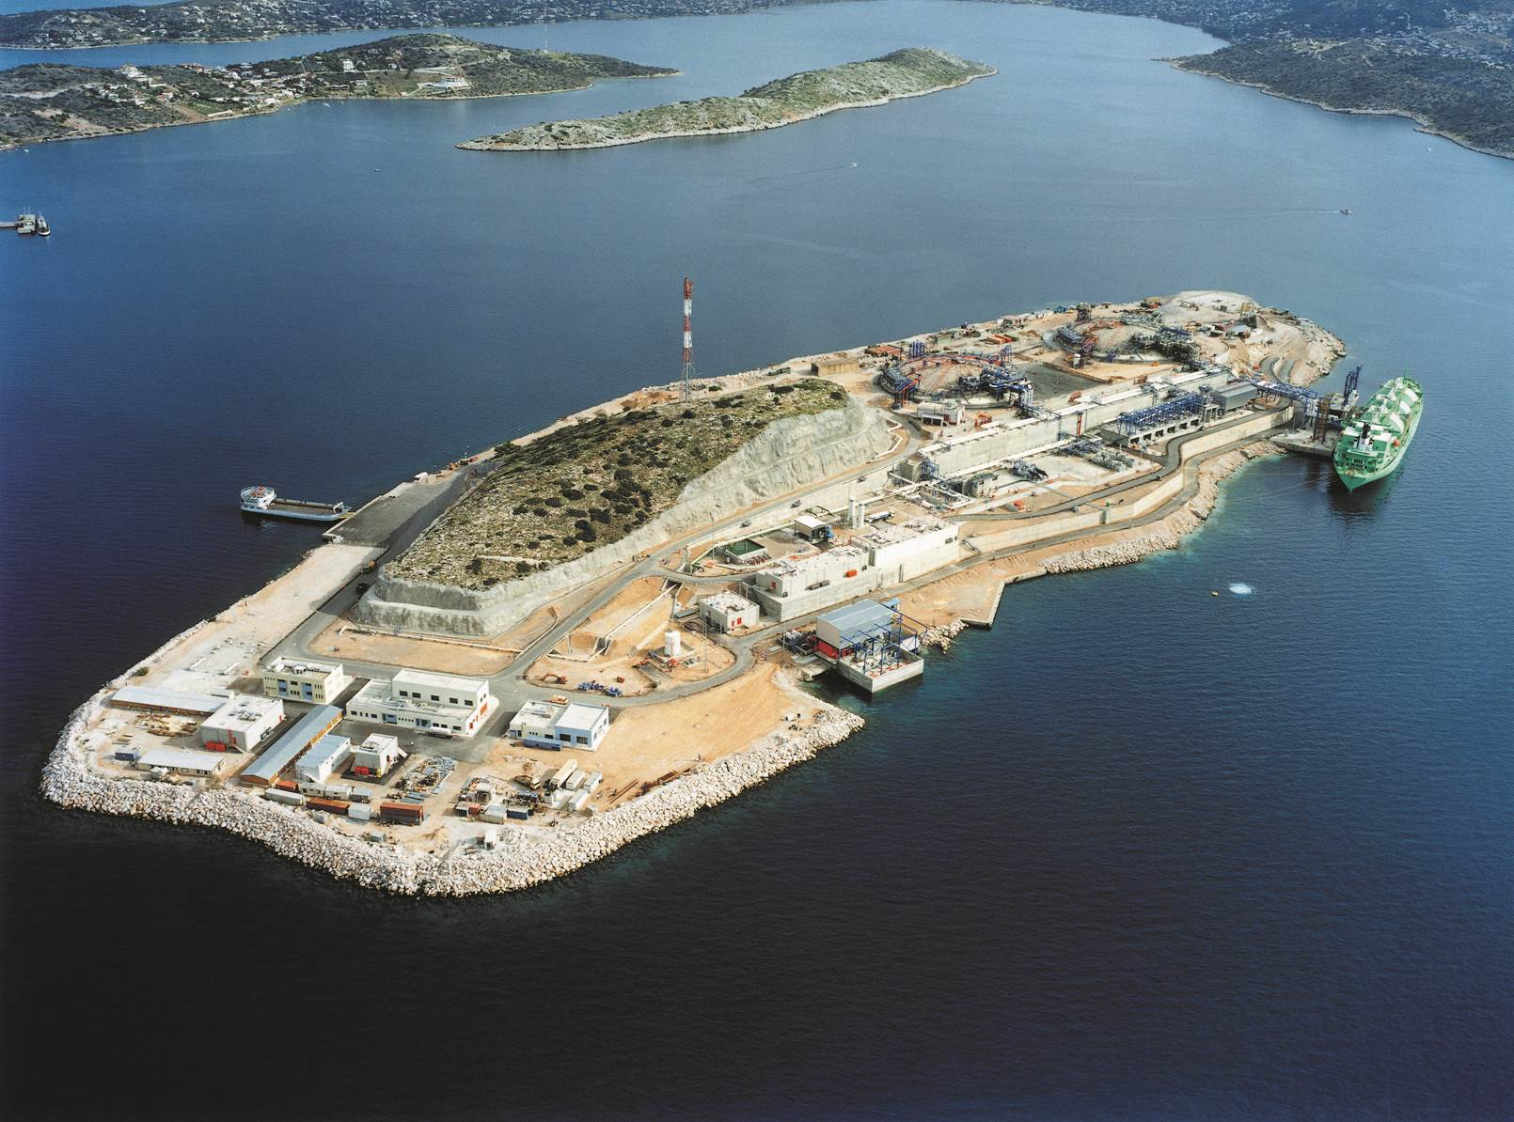

BALANCING MANUAL
Revision 1

General Provisions

Article 1.1
- This Gas Balancing Manual (hereinafter referred to as the ‘Manual’) shall be implemented in complementarity with the provisions of Law 4001/2011, the NNGS Network Code (hereinafter referred to as the ‘Code’) and the relevant Framework Agreements for Natural Gas Transmission concluded between Transmission Users and Operator (hereinafter referred to as the ‘Transmission Agreement’).
- The terms referred to in this Manual shall have the meaning ascribed to them in Law 4001/2011, the Code, the Transmission Agreement or its individual provisions.
- Within 30 days from the end of each Month, the Operator shall submit a report to RAE on the balancing market. The Report shall include, for each Day (d) of the Month, the quantities of Natural Gas purchased or sold by the Operator, the Balancing Gas Marginal Buy and Sell Prices and the Average Weighted Gas Price.

CHAPTER 2

Trading procedures on the Trading Platform

Article 2.1

Announcement on the Auctioning for Short-term Standardised Products
1. The Operator shall announce on the Electronic Information System and shall notify the Trading Platform Operator of his intention to purchase or sale Short Term Standardised Products through an auction, forty five (45) minutes at the latest before the time on which the respective auction starts, in accordance with the provisions of the Trading Platform Regulation.
2. The announcement on the Electronic Information System and the notice to the Trading Platform Operator shall include the following as a minimum:
- Whether the Operator’s balancing action relates to the purchase or sale of Balancing Gas.
- The quantity of Balancing Gas to which the Operator’s balancing action relates.
- The Short-Term Standardised Product to which the auction relates.
- Details on the procedure and the contents of the communication between the Operator and the Trading Platform Operator shall be set out in the Trading Platform Agreement.

CHAPTER 3

Daily Imbalance Settlement Prices

Article 3.1

Small Adjustment

- For the calculation of the Balancing Gas Marginal Buy Price, the small adjustment, as provided for in Article [53^{A}] paragraph [3b] of the Code, is set at ten percent (10%) of the Average Weighted Gas Price on Day (d).
- For the calculation of the Balancing Gas Marginal Sell Price, the small adjustment, as provided for in Article [53^{A}] paragraph [4b] of the Code, is set at ten percent 10% of the Average Weighted Gas Price on Day (d).

Article 3.2

Substitution prices
- Where on Day (d) the Operator did not engage in a Balancing Action by purchasing or selling short-term standardised products, the following rules shall apply:
A) The Balancing Gas Marginal Buy Price on Day (d) shall be equal to the Weighted Average Gas Price on Day (d) plus the small adjustment specified in point A) of Article [3.1].
B) The Balancing Gas Marginal Sell Price on Day (d) shall be equal to the Average Gas Price on Day (d) less the small adjustment specified in point B) of Article [3.1].
- Where on Day (d) the Operator submitted an offer to purchase or sell Balancing Gas via Short-Term Standardised Products on the Trading Platform but no relevant transactions were entered into, the following rules shall apply:

A) For the purpose of calculating the Balancing Gas Purchase Limit Price on day (d), the Substitution Price specified in Article [53A](6)(i) of the Code shall be equal to the Balancing Gas Marginal Buy Price on the most recent Day on which the Operator entered into a balancing action by purchasing short-term standardised products.
B) For the purpose of calculating the Balancing Gas Sale Limit Price on day (d), the Substitution Price specified in Article [53A](6)(ii) of the Code shall be equal to the Balancing Gas Marginal Sell Price on the most recent Day on which the Operator entered into a balancing action by selling short-term standardised products.
- Where on Day (d) no transactions were entered into on the Trading Platform in accordance with the provisions of Article [53A](5) of the Code or the conditions for the Platform Minimum Liquidity Limit are not met in accordance with the provisions of Article [3.3], the Weighted Average Gas Price for Day (d) shall be equal to the Weighted Average Gas Price on the most recent Day on which the conditions for the Platform Minimum Liquidity Limit are met. On each Day from the Trading Platform start date until the Day on which the conditions in relation to the Platform Minimum Liquidity Limit are met for the first time, where the Average Weighted Gas Price is to be used, the last Gas Balancing Reference Price announced by the Operator shall be used.

Article 3.3

Platform Minimum Liquidity Limit
- The Platform Minimum Liquidity Limit for Day (d) means a minimum quantity of Natural Gas which must have been traded on the Trading Platform using title products which relate to Day (d) and whose purchase and sale took place on Day (d-1) and Day (d).

- The Platform Minimum Liquidity Limit or each Day (d) is equal to 200,000 KWh.

