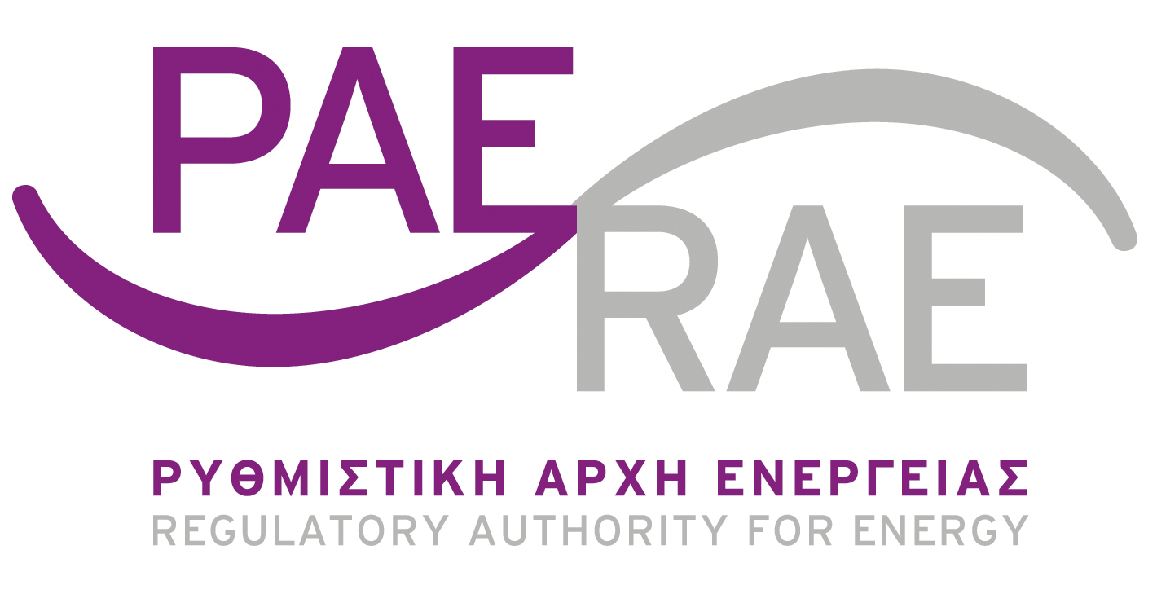

Athens, 1st March 2023

# Congestion revenues management report

## Background

1. According to Regulation (EC) No 943/2019 of the European Parliament and of the Council of 5th June 2019 on the internal market for electricity, and in particular article 19 of the Regulation, the Greek Regulatory Authority for Energy (RAE) shall by 1st March each year publish a report presenting the amount and the use of the congestion revenues collected for the 12-month period ending on 31 December of the previous year.
2. The following objectives shall have priority with the respect to the allocation of any revenues resulting from the allocation of cross-zonal capacity:
3. guaranteeing the actual availability of the allocated capacity including firmness compensation; or
4. maintaining or increasing cross-zonal capacities through optimisation of the usage of existing interconnectors by means of coordinated remedial actions, where applicable, or covering costs resulting from network investments that are relevant to reduce interconnector congestion.
5. Where the priority objectives set out in paragraph 2 have been adequately fulfilled, the revenues may be used as income to be taken into account by RAE when approving the methodology for calculating network tariffs or fixing network tariffs, or both. The residual revenues shall be placed on a separate internal account line until such a time as it can be spent for the purposes set out in paragraph 2.

The use of revenues in accordance with point (a) or (b) of paragraph 2 shall be subject to a methodology proposed by the transmission system operators after consulting regulatory authorities and relevant stakeholders and after approval by ACER.

1. The Greek Transmission System Operator, ADMIE, is responsible for the management of the congestion revenues, resulting from the capacity allocation for the interconnections between Greece and Italy, Albania, FYROM, Bulgaria and Turkey achieved through yearly, monthly and daily auctions. More specifically, the “Joint Allocation Office” (JAO[1]) facilitates the explicit auctions (in yearly, monthly and daily resolution) for the interconnector on the border with Italy. ADMIE, for the border with Bulgaria, applies the joint auctions scheme together with the Bulgarian TSO, ESO EAD, with ADMIE performing the yearly and daily auctions. Regarding the borders with Albania and Turkey, the auctions for the allocation of capacity are performed (in yearly, monthly and daily resolution) from “South East Europe Coordinated Auction Office” (SEE CAO[2]). Finally, for the last border with FYROM, ADMIE is responsible for allocating only 50% of the interconnection capacity, with the neighboring TSO, namely MEPSO, being responsible for the remaining 50%. In that case, ADMIE facilitates yearly, monthly, and daily auctions for the allocation of the capacity.

## Congestion revenues

1. Each year ADMIE provides RAE with a detailed analysis of the amount of revenues earned through the auctions. The table below presents the revenues per border of the year 2022.



The congestion revenues received from January 2022 until December 2022 amounted to 109,7 million €, decreasing by 170,3% compared to the revenues received between January 2021 and December 2021, due to the increase in revenues from exports.

1. The analysis of the revenues shows that 70,4% of the revenues comes from auctions for capacity for imports and 29,6% for exports. The analysis per border shows that 34,8% of the revenues comes from capacity auctions between Greece and Bulgaria, 10,5% from auctions between Greece and North Macedonia, 33,6% from auctions between Greece and Italy, 7,1% from auctions between Greece and Albania, and 14,1% from auctions between Greece and Turkey. Moreover, it should be mentioned that the shares for exports to Bulgaria and Turkey are almost zero.

Additionally, the yearly observations apply mostly also in monthly basis, with the revenues form imports from Italy, Bulgaria and North Macedonia representing the major share of the revenues from the allocation of capacity rights on interconnections.

## Congestion revenues management

1. With the Decision 868, issued on 18/09/2019, RAE set the amount of € **70,000,000**, as the maximum that could be withdrawn from the yearly congestion revenues, when approving network tariffs.
2. In addition, according to the Grid Code, subsection 11.11:

“In the *Account Λ-E is registered as revenue the amount collected by the Greek Transmission System Operator, ADMIE, for the allocation of the capacity of interconnections. The total amount collected is available exclusively for the purposes set out in the provisions of the Regulation (EC) No 943/201.*”

1. With the Decision **910/2022**, RAE approved the usage of **€68.674.943,39** respectively, for the reduction of Required Revenue and Transmission Tariffs.

1. <http://www.jao.eu/main>
2. <http://www.seecao.com/>